EXTERNAL GEAR INDICATOR SCHEMATICS

7 segment digit - common cathode (ground in the middle)
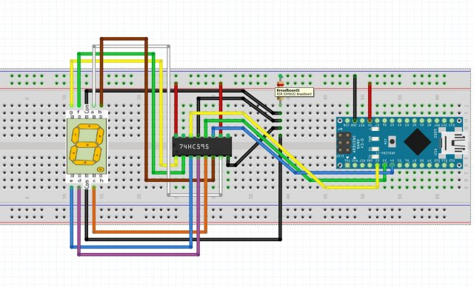
White - A segment - Q7 PIN on 74HC595
Brown -B segment - Q6 PIN
Orange - C segment - Q5 PIN
Purple - D segment - Q4 PIN
Blue - E segment - Q3 PIN
Green - F segment - Q2 PIN
Yellow - G segment - Q1 PIN
If u want to use DP/H (DOT), connect it to the second left top pin Q0, but its not used in the sketch right now.
Data PINs:
DS (serial data input) - D2 on Arduino
ST_CP (Storage register clock pin "Latch pin") - D3
SH_CP (Shift register clock pin) - D4
Resistor R220 Ohm. (used just one on cathodes, but its better to use 7 resistors, one for every led diode - between Qpins and display)

